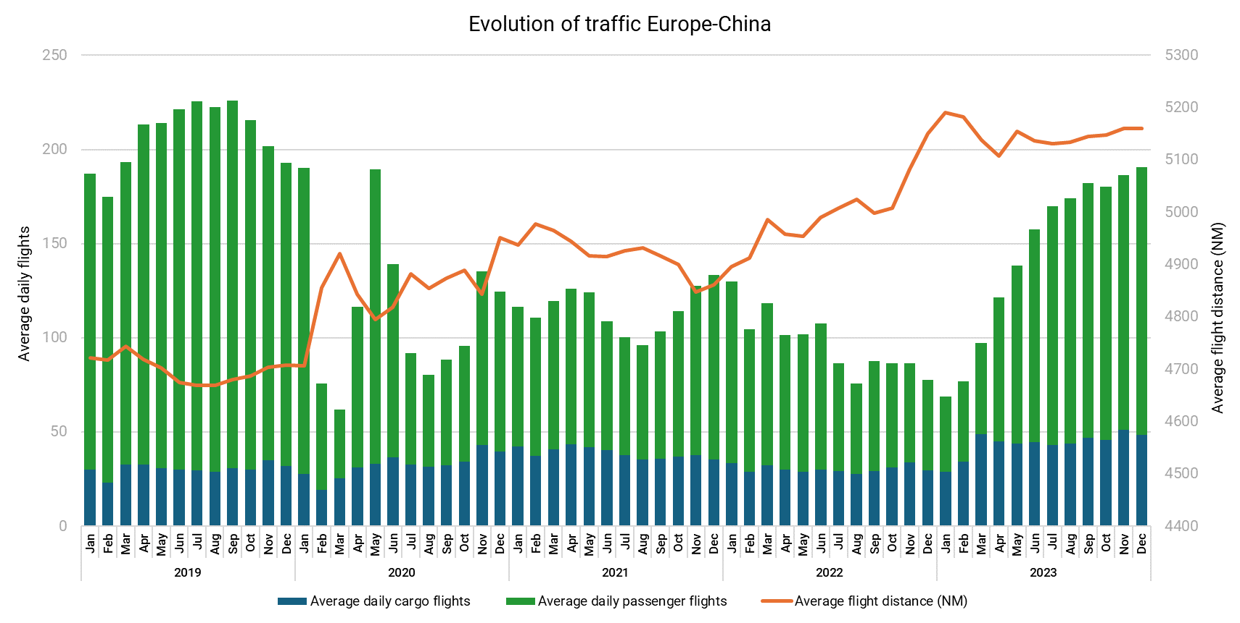

The evolution of air traffic between Europe and China from January 2019 to December 2023 has been significantly influenced by major global events, including the COVID-19 pandemic and the war in Ukraine. In 2019, air traffic was robust, with average daily passenger flights peaking at around 200 per day, while cargo flights remained steady at approximately 30 flights per day. However, the onset of the COVID-19 pandemic in early 2020 caused a dramatic decline in passenger flights, plummeting to nearly 50 flights per day by April 2020 due to global travel restrictions and reduced demand driven by health concerns. Cargo flights, in contrast, demonstrated resilience during this period, maintaining a relatively stable level despite some fluctuations.

The gradual recovery phase began in mid-2021 as travel restrictions were lifted and passenger demand started to return cautiously. Passenger flights saw a slow but steady increase, though they did not reach pre-pandemic levels by the end of 2023. Cargo flights continued to be stable, reflecting the ongoing demand for air cargo services. A notable trend during this recovery phase was the increase in average flight distances, starting from mid-2021 and continuing through to the end of 2023, reaching over 5100 nautical miles on average. This increase in distance is likely due to changes in flight routes, influenced by airspace restrictions and operational optimizations.

The war in Ukraine, which began on 24 February 2022, added another layer of complexity to the air traffic landscape. The conflict led to airspace closures and route adjustments, further contributing to the observed increase in average flight distances. Despite these challenges, the recovery in passenger flights continued, although at a slower pace than initially anticipated. This period underscores the aviation industry's adaptability and resilience in the face of geopolitical tensions and operational disruptions.

In conclusion, the data highlights the profound impact of the COVID-19 pandemic on air travel between Europe and China, with a sharp decline in passenger flights and a resilient cargo sector. The subsequent recovery phase shows a gradual return in passenger traffic, coupled with an increase in average flight distances, emphasizing the aviation industry's ability to adapt to changing circumstances. The ongoing war in Ukraine continues to influence flight routes and operational strategies, demonstrating the need for continued vigilance and flexibility in the aviation sector. For more detailed insights and data, visit EUROCONTROL Data Snapshots.